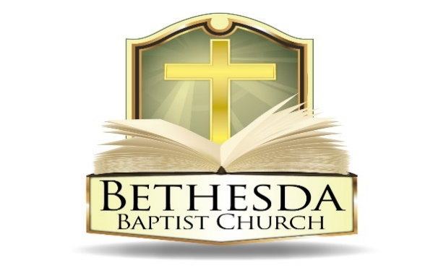
Covenant Partner News
Sunday, April 6, 2025
Volume 5 Issue 14

RECURRING EVENTS

Hour of Power & Bible Study
Each Tuesday at 6:00pm followed by Bible Study at 7:00pm via *ZOOM:
https://us02web.zoom.us/j/83096366206?pwd=J7wZ8bwAcBA1snP5SgRuYhW4E2DsU.1
Meeting ID: 830 9636 6206 Passcode: 199366
To use your cell phone or land line, *please dial: 1. 301. 715. 8592
Meeting ID: 830 9636 6206#; Passcode: 199366#
We encourage all members to submit prayer requests as the Holy Spirit leads by 12:00 Noon on Monday.

Open Praise Forum & Bible Study
Every Tuesday leading up to Communion Sunday at 6:00pm followed by
Bible Study at 7:00pm via ZOOM and on conference line referenced above. *

Bible Study Young Adult Edition
Each Wednesday at 7:30pm EST and 6:30pm CST via Zoom.
Register by text at 202-262-4476 or email kgoady07@gmail.com.

Men’s Prayer Hour
Each Wednesday at 9:00pm via conference call: 1.717.908.1972; Access 875378#

Women’s Prayer Hour
Each 4th Saturday at 9:00am via conference call: 1.605.313.5143; Access code 654522#

Questions and Answers
Held each 4th Sunday at 6:00pm via conference call: 1.717.908.1972; Access code 875378#
Please submit your questions today by email to: SoulCare@Bethesdaweb.org or in Q&A box located on the table outside of the church office.

Bible Study
Each Thursday at 12:00 Noon via conference call: 1.717.908.1972; Access code 875378#

THIS WEEK EVENTS

Thursday, April 10
6:30pm Christian Education Ministry Mtg. via conference call:
1.717.908.1972; Access code 875378#

Friday, April 11
6:00am to 6:00pm Prayer and Fasting for our nation
6:00pm Good News Club, Rooms 118 and 120

Saturday, April 12
9:00am Girl Scouts Troop 44006 Meeting, Fellowship Hall
11:30am Combined Choir Rehearsal, Room 120
3:00pm Spiritual Friends Network conference call:
1.717.908.1972; Access code 875378#

ANNOUNCEMENTS

Leadership Training Saturday, April 5, at 9:00am
Community Day Planning Meeting Thursday, April 17 via conference call
Good Friday Service Friday, April 18, at 12:00 noon
Prayer Vigil and Fasting Saturday, April 19 via zoom
Resurrection Sunday Sunday, April 20

TUESDAY BIBLE STUDY
Pastor Eric Teitelman of House of David Ministries will be our instructor for Tuesday Night Bible Study on April 1, 8 and 22 via *zoom. He will teach on Romans 9-11, God is not finished with Israel. Pastor Eric is a Jewish follower of Jesus.

The Thursday Bible Study group will merge with Tuesday’s Bible Study group at 7:00pm to hear Pastor Teitelman. There is no Thursday Bible Study.

To use your cell phone or landline please call: 1. 301. 715. 8592, Meeting ID: 830 9636 6206#; Passcode: 199366#
*https://us02web.zoom.us/j/83096366206?pwd=J7wZ8bwAcBA1snP5SgRuYhW4E2DsU.1
Meeting ID: 830 9636 6206 Passcode: 199366

CEF 2025 SPRING LUNCHEON
Come One, Come All!
Please join Child Evangelism Fellowship (CEF) of the Greater Washington D.C. Metro Area for its 2025 Spring Luncheon. The theme for this event is “Partnering Together to Reach the Next Generation.” (Matthew 18:14).

The event will be held 1:00 p.m.- 3:00 p.m. on Saturday, April 12, 2025, at Woodstream Church, 9800 Lottsford Road, Bowie Maryland. The early bird price is $30.00 through April; $35.00 after that date.

To reserve your seat, go To: https://cefwashingtondc.org. Click Donate at the top right on the homepage, and follow the prompts, or see one of the following CEF Board Members: Deaconess LaVerne Brown, Deaconess Doris Young, or Trustee Mary Armstead.

Looking forward to seeing you there as we celebrate the mighty work the Lord is doing through CEF.
ANNOUNCEMENTS CONTINUED:

ARCHIVAL LIBRARY
Ministry Leaders, Recording Secretaries and Liaisons, please submit your ministry meetings and service reports by April 13, 2025. Thank you for your cooperation.

PRAYER AND FASTING 6:00am to 6:00pm each Friday between now and Good Friday, April 18:

- Pray that our nation and its leaders fear the name of the Lord and seek His glory, not their own--Psalm 102:15
- Pray that God would send renewal to our nation and leaders and turn the hearts of many to Christ-- Acts 3:20
- Pray that our nation would abandon its idols and worship the one true God-- 1 Chronicles 16: 28
- Pray that those who are afraid of what is happening would turn their hearts to the one and only living God, who is our only source of security--Psalm 62:6
- Pray for wise political policies and the elimination of injustice--Esther 4:3

CLINTON BAPTIST CHURCH
On Friday, April 18, at 7:00PM, Pastor Thompson will be one of 7 speakers at
Clinton Baptist Church Good Friday Service
8701 Woodyard Rd, Clinton, MD 20735

LOTT CAREY
Annual Resurrection Monday Services
Monday, April 21, 2025, at 12:00 Noon
St. Matthew Baptist Church
2001 Brooks Drive
Capitol Heights, MD 20743
Guest Preacher: Dr. John Kinney

ANNOUNCEMENTS CONTINUED:

WOMEN’S MINISTRY Saturday, May 10th, in person.
“Total Woman Self Care Awareness Fellowship” Theme: “Renew! Restore! Refresh!” It is an opportunity for women and female youth to come together with other churches, our community, and the Bethesda Family. We are planning activities designed to give information about the development of prayer life, hair care, skin care, healthy eating, exercise, fashion and goal setting as well as involvement and participation. Register online here.

COMFORT MINISTRY – A CALL TO SERVE
"Comfort ye, comfort ye, my people, saith the Lord." – Isaiah 40:1

The Comfort Ministry of Bethesda Baptist Church is dedicated to providing prayer, consolation, and support to our bereaved members. As we revive this vital ministry, we invite compassionate individuals to join us in serving those in their time of need.

By becoming a part of this ministry, you will not only bring comfort to others but also experience the joy and fulfillment that comes from serving.
If you feel called to this mission, we would love to have you join us. For more information, please contact Sis. LaVerne Brown or Sis. Margaret Elliott.

